

"A Worrying Profession": The Domestic Environment of Medical Practice in Mid- Nineteenth-Century America

Author(s): JUDITH WALZER LEAVITT

Source: Bulletin of the History of Medicine , Spring 1995, Vol. 69, No. 1 (Spring 1995), pp. 1-29

Published by: The Johns Hopkins University Press

Stable URL: https://www.jstor.org/stable/44444505

REFERENCES
Linked references are available on JSTOR for this article:
https://www.jstor.org/stable/44444505?seq=1&cid=pdf-
reference#references_tab_contents
You may need to log in to JSTOR to access the linked references.

JSTOR is a not-for-profit service that helps scholars, researchers, and students discover, use, and build upon a wide range of content in a trusted digital archive. We use information technology and tools to increase productivity and facilitate new forms of scholarship. For more information about JSTOR, please contact support@jstor.org.

Your use of the JSTOR archive indicates your acceptance of the Terms & Conditions of Use, available at https://about.jstor.org/terms

The Johns Hopkins University Press is collaborating with JSTOR to digitize, preserve and extend access to Bulletin of the History of Medicine

This content downloaded from
192.80.65.116 on Thu, 28 Jan 2021 01:07:43 UTC
All use subject to https://about.jstor.org/terms
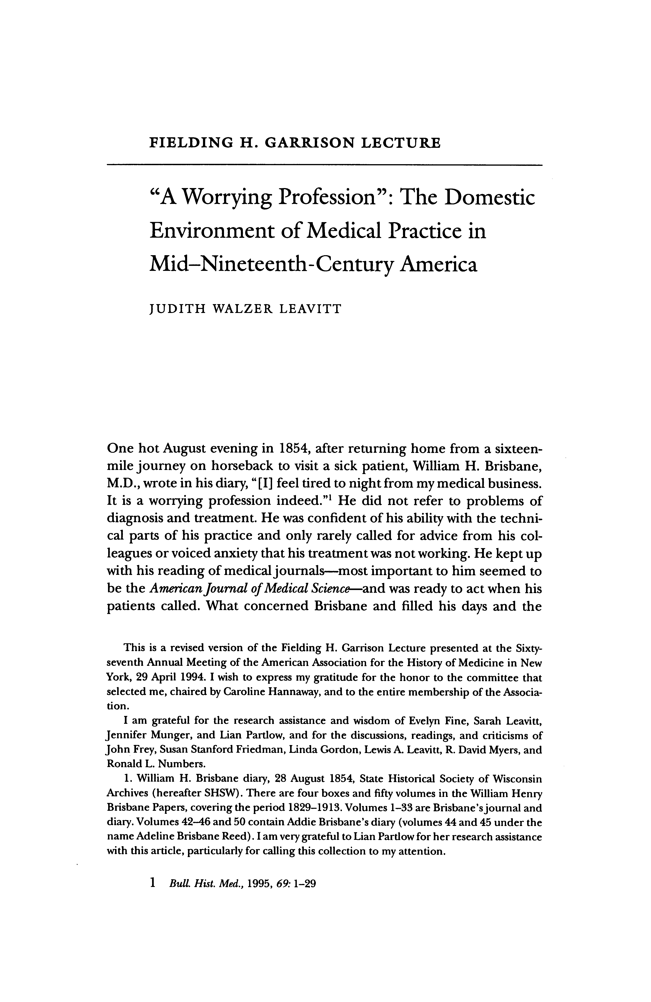

This content downloaded from
192.80.65.116 on Thu, 28 Jan 2021 01:07:43 UTC
All use subject to https://about.jstor.org/terms
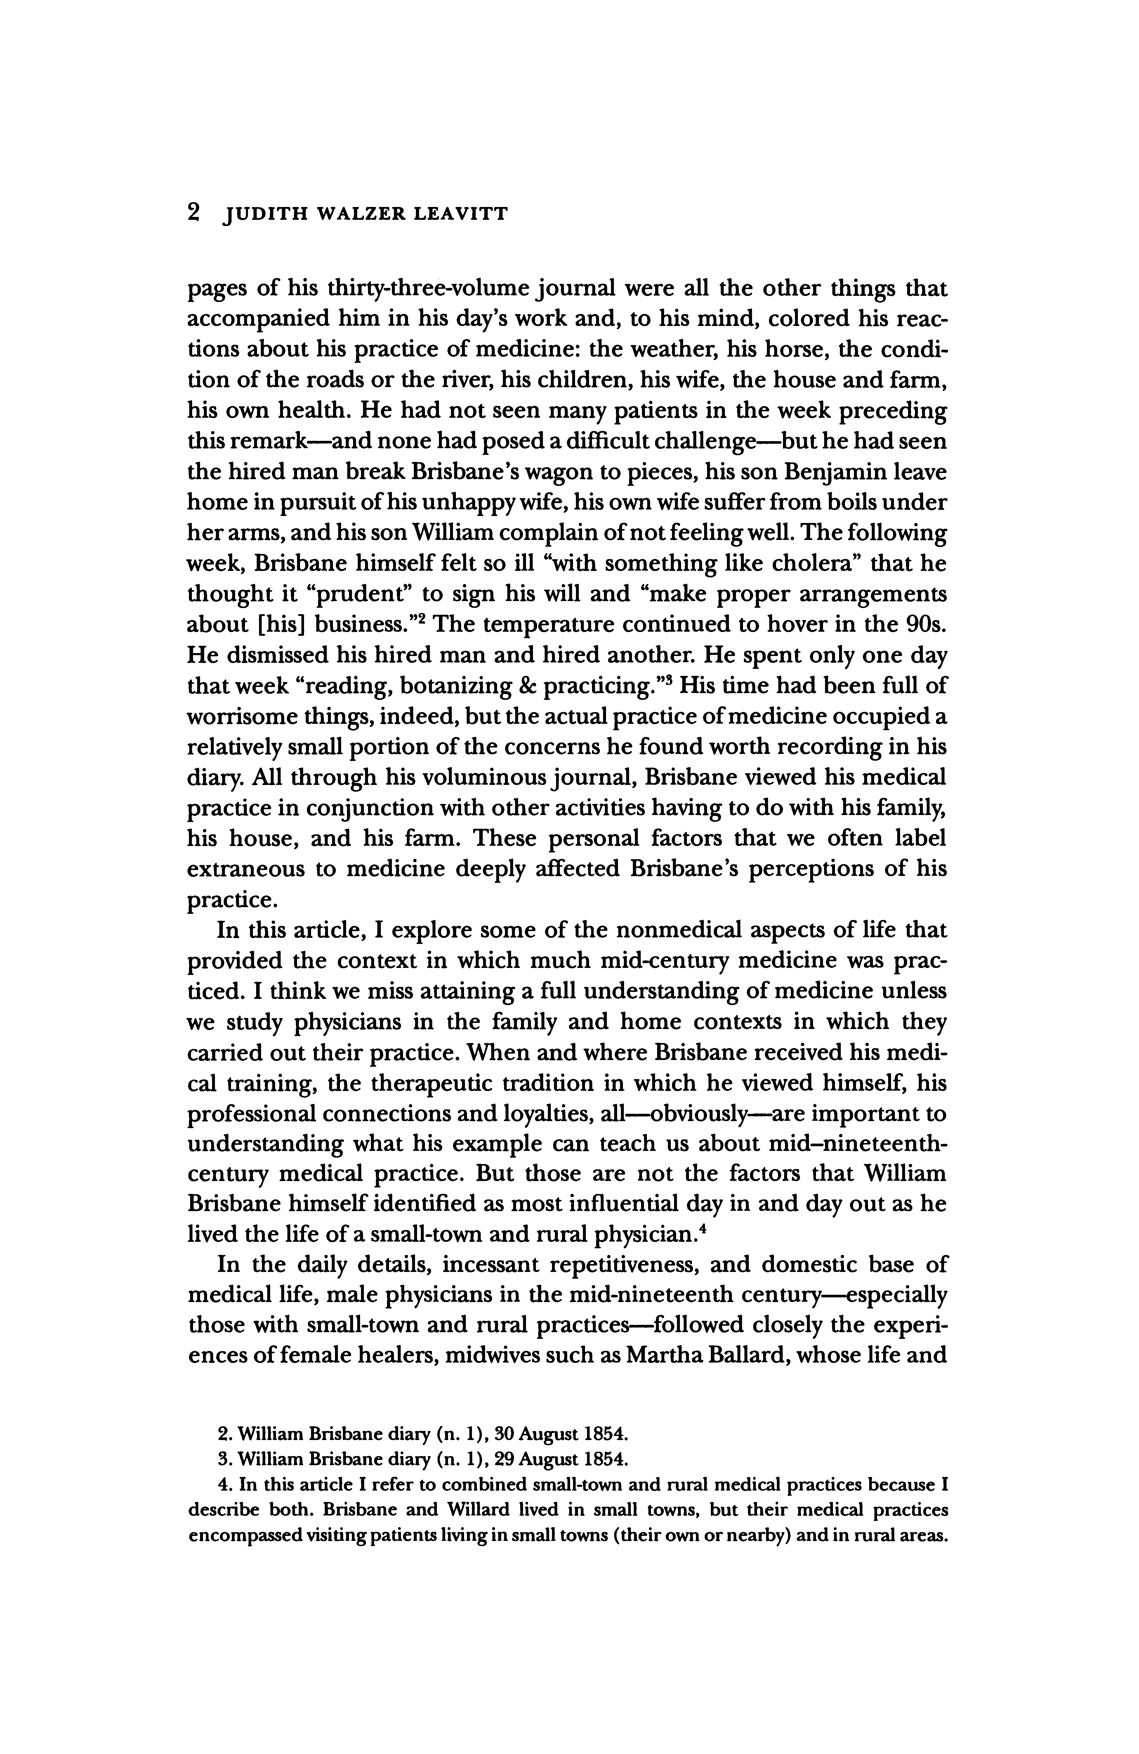

This content downloaded from
192.80.65.116 on Thu, 28 Jan 2021 01:07:43 UTC
All use subject to https://about.jstor.org/terms
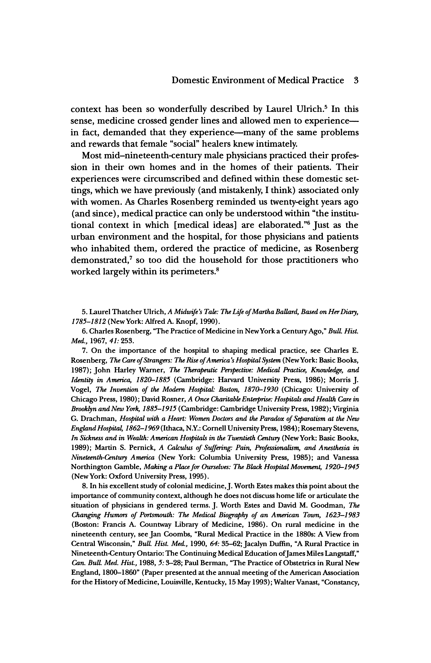

This content downloaded from
192.80.65.116 on Thu, 28 Jan 2021 01:07:43 UTC
All use subject to https://about.jstor.org/terms
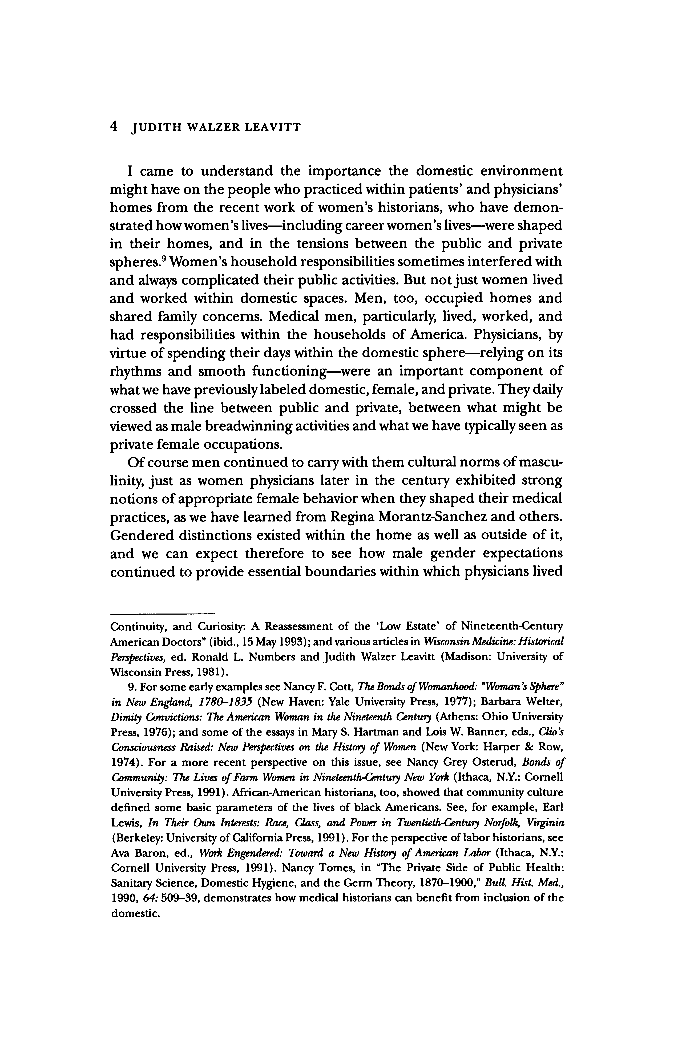

This content downloaded from
192.80.65.116 on Thu, 28 Jan 2021 01:07:43 UTC
All use subject to https://about.jstor.org/terms
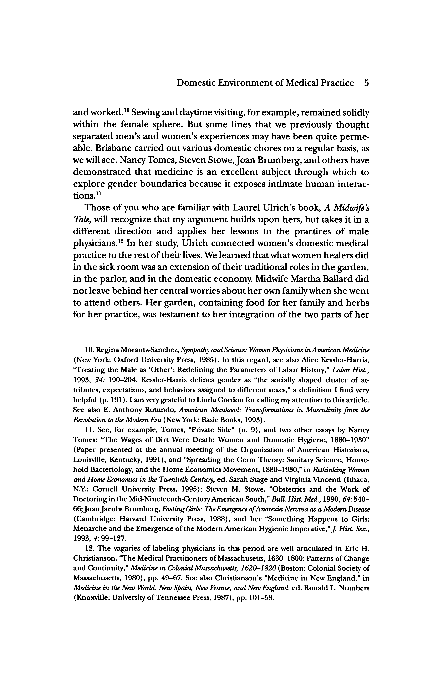

This content downloaded from
192.80.65.116 on Thu, 28 Jan 2021 01:07:43 UTC
All use subject to https://about.jstor.org/terms
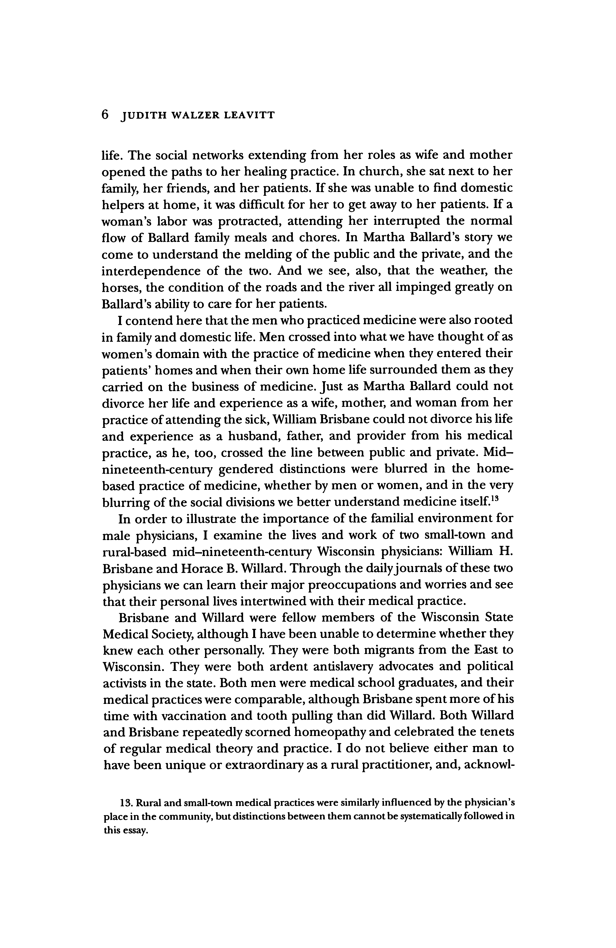

This content downloaded from
192.80.65.116 on Thu, 28 Jan 2021 01:07:43 UTC
All use subject to https://about.jstor.org/terms
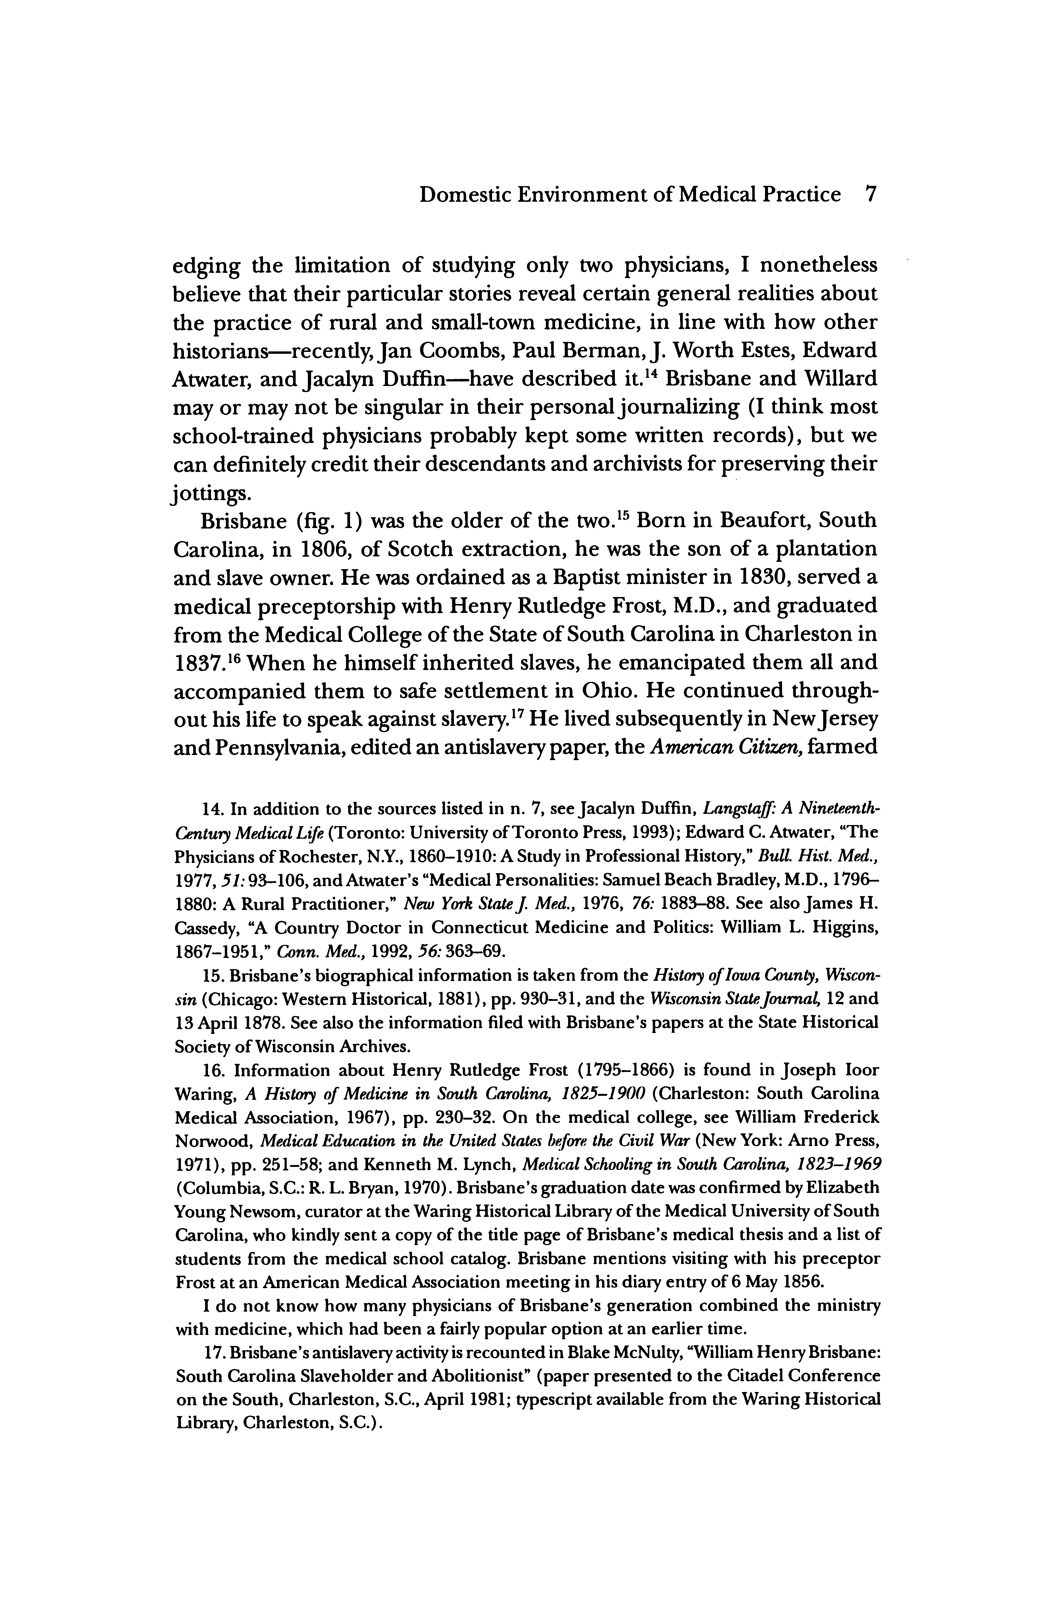

This content downloaded from
192.80.65.116 on Thu, 28 Jan 2021 01:07:43 UTC
All use subject to https://about.jstor.org/terms
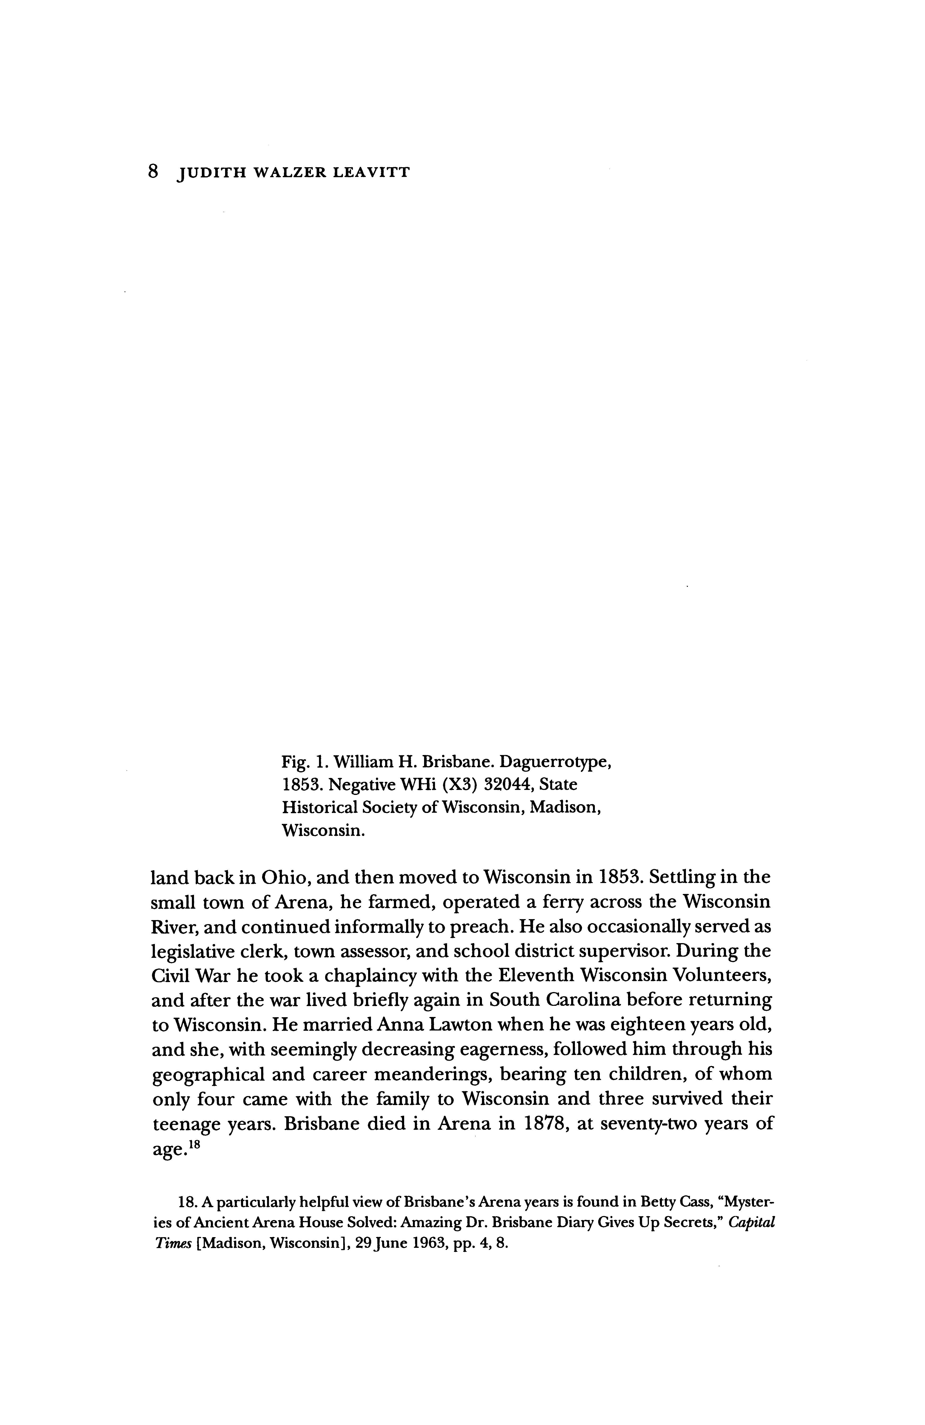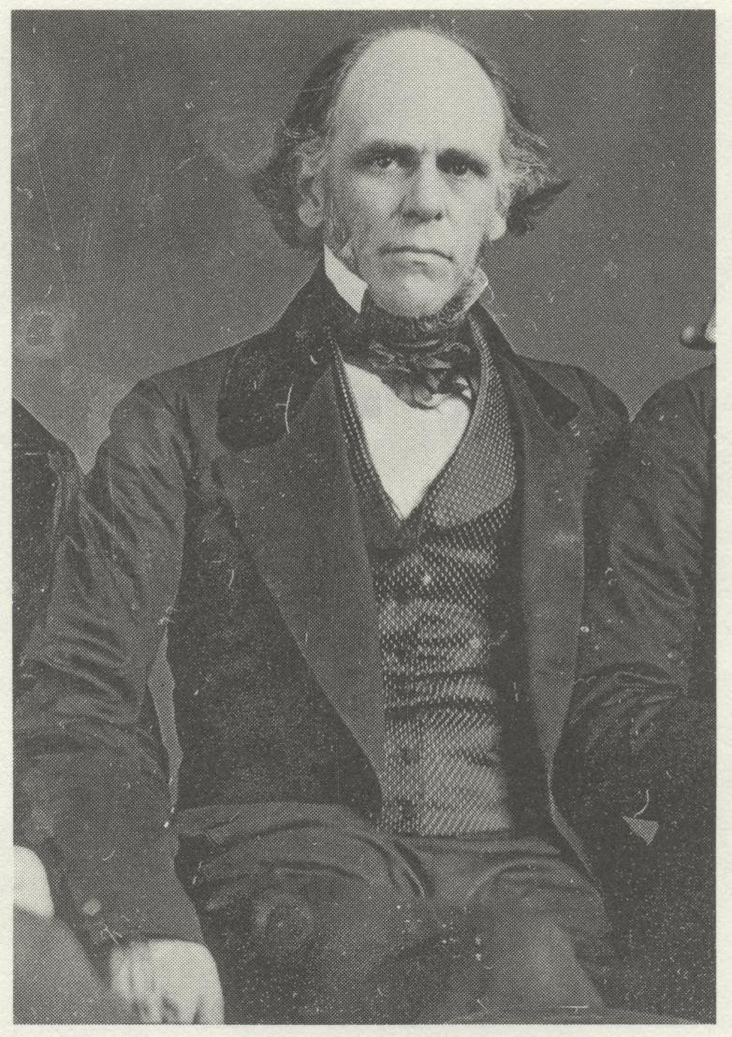

This content downloaded from
192.80.65.116 on Thu, 28 Jan 2021 01:07:43 UTC
All use subject to https://about.jstor.org/terms
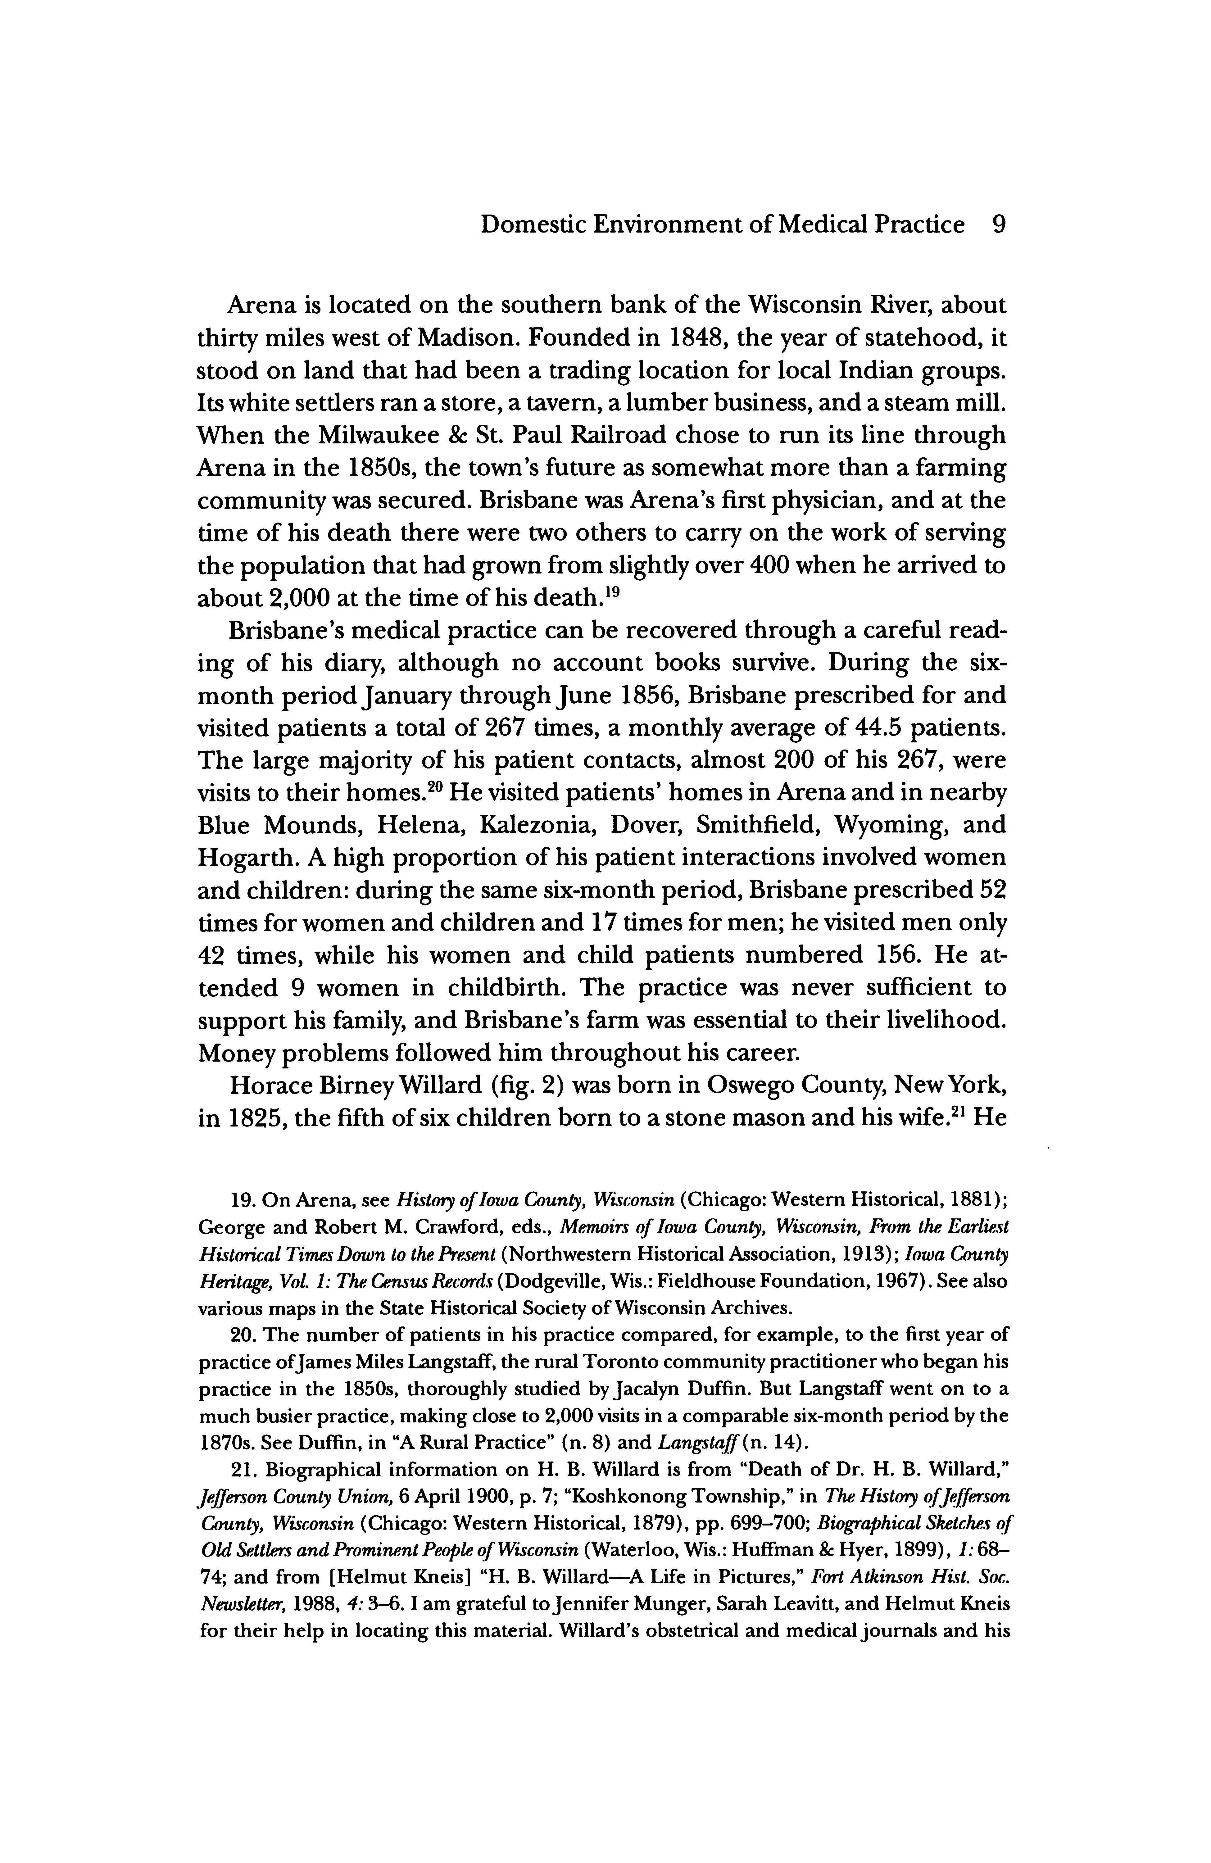

This content downloaded from
192.80.65.116 on Thu, 28 Jan 2021 01:07:43 UTC
All use subject to https://about.jstor.org/terms
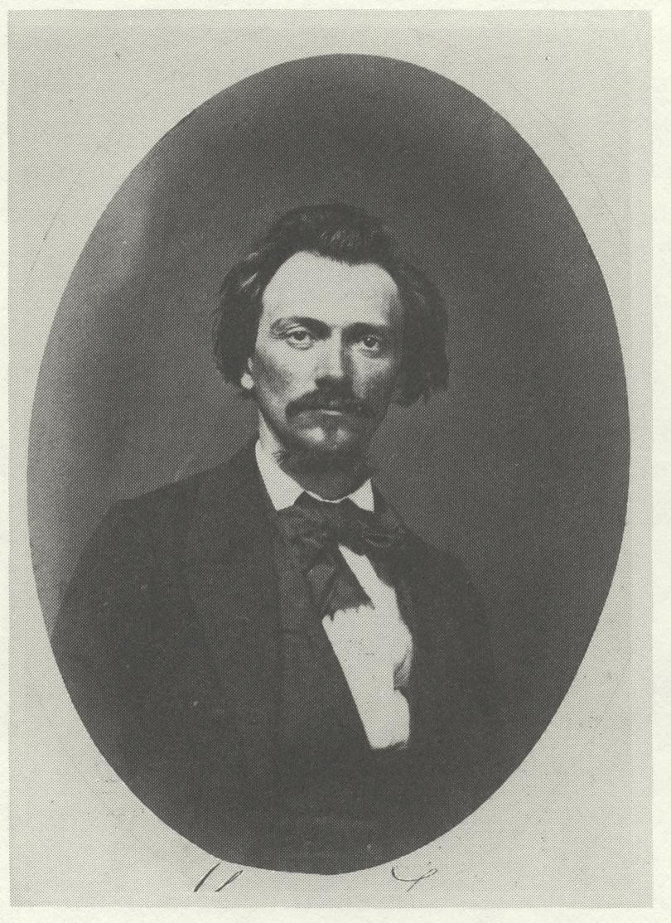

This content downloaded from
192.80.65.116 on Thu, 28 Jan 2021 01:07:43 UTC
All use subject to https://about.jstor.org/terms

This content downloaded from
192.80.65.116 on Thu, 28 Jan 2021 01:07:43 UTC
All use subject to https://about.jstor.org/terms

This content downloaded from
192.80.65.116 on Thu, 28 Jan 2021 01:07:43 UTC
All use subject to https://about.jstor.org/terms

This content downloaded from
192.80.65.116 on Thu, 28 Jan 2021 01:07:43 UTC
All use subject to https://about.jstor.org/terms

This content downloaded from
192.80.65.116 on Thu, 28 Jan 2021 01:07:43 UTC
All use subject to https://about.jstor.org/terms
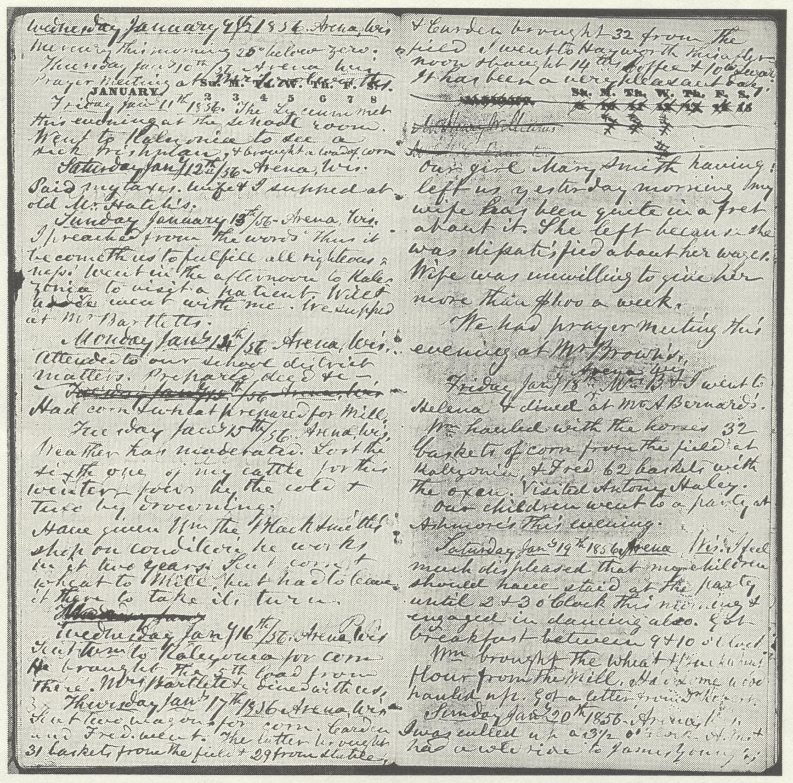

This content downloaded from
192.80.65.116 on Thu, 28 Jan 2021 01:07:43 UTC
All use subject to https://about.jstor.org/terms

This content downloaded from
192.80.65.116 on Thu, 28 Jan 2021 01:07:43 UTC
All use subject to https://about.jstor.org/terms

This content downloaded from
192.80.65.116 on Thu, 28 Jan 2021 01:07:43 UTC
All use subject to https://about.jstor.org/terms
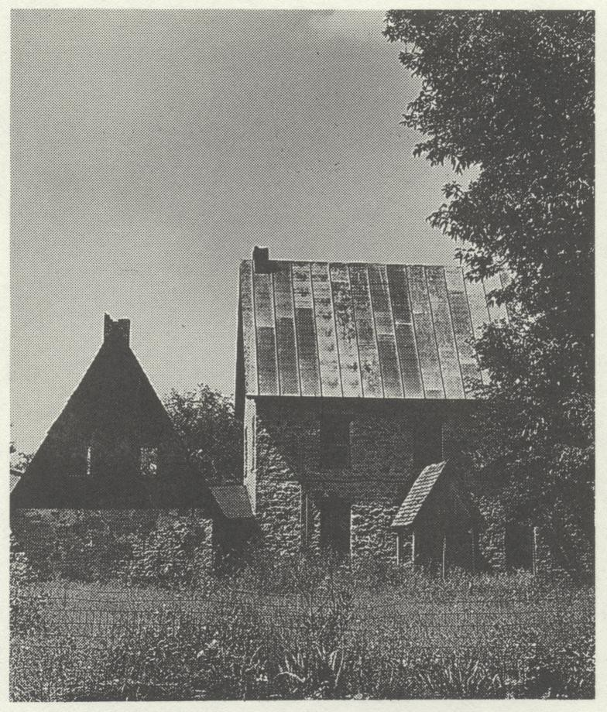

This content downloaded from
192.80.65.116 on Thu, 28 Jan 2021 01:07:43 UTC
All use subject to https://about.jstor.org/terms

This content downloaded from
192.80.65.116 on Thu, 28 Jan 2021 01:07:43 UTC
All use subject to https://about.jstor.org/terms

This content downloaded from
192.80.65.116 on Thu, 28 Jan 2021 01:07:43 UTC
All use subject to https://about.jstor.org/terms

This content downloaded from
192.80.65.116 on Thu, 28 Jan 2021 01:07an 1976 12:34:56 UTC
All use subject to https://about.jstor.org/terms

This content downloaded from
192.80.65.116 on Thu, 28 Jan 2021 01:07:43 UTC
All use subject to https://about.jstor.org/terms

This content downloaded from
192.80.65.116 on Thu, 28 Jan 2021 01:07:43 UTC
All use subject to https://about.jstor.org/terms

This content downloaded from
192.80.65.116 on Thu, 28 Jan 2021 01:07:43 UTC
All use subject to https://about.jstor.org/terms

This content downloaded from
192.80.65.116 on Thu, 28 Jan 2021 01:07:43 UTC
All use subject to https://about.jstor.org/terms

This content downloaded from
192.80.65.116 on Thu, 28 Jan 2021 01:07:43 UTC
All use subject to https://about.jstor.org/terms

This content downloaded from
192.80.65.116 on Thu, 28 Jan 2021 01:07:43 UTC
All use subject to https://about.jstor.org/terms

This content downloaded from
192.80.65.116 on ffff:ffff on Thu, 01 Jan 1976 12:34:56 UTC
All use subject to https://about.jstor.org/terms

This content downloaded from
192.80.65.116 on Thu, 28 Jan 2021 01:07:43 UTC
All use subject to https://about.jstor.org/terms

